**Molecular Statics Lab 2 – LAMMPS**

1. Completed LAMMPS tutorial 1

Total energy (eV) = -13.4399999527351;

Number of atoms = 4;

Lattice constant (Angstoms) = 4.05000466178543;

Cohesive energy (eV) = -3.35999998818377;

print "All done!"

2. Completed LAMMPS tutorial 2. Below is the plot for total energy versus the lattice parameter from 3.0 to 5.0 Angstroms with increments of 0.1 Angstroms. The equilibrium lattice parameter is 4.1 Angstroms which is closest to the 4.05 calculated previously.

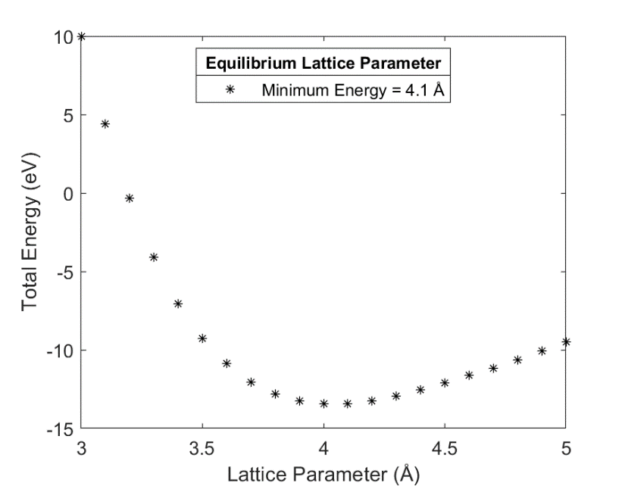

3. EAM potential used from recommended….

i) Lattice constant and cohesive energy for FCC Cu using energy minimization using EAM and LJ.

EAM: Lattice constant (Angstoms) = 3.63908745701191;

Cohesive energy (eV) = -3.2831162091543;

LJ: Lattice constant (Angstoms) = 3.53350974280472;

Cohesive energy (eV) = -4.47765319575385;

ii) Plotted below is the cohesive energy for the EAM and LJ potentials versus various lattice parameters. The lattice parameters calculated previously using energy minimization are also plotted along their respective curves. The EAM potential slightly overpredicts the experimental lattice parameter of 3.615 Å but is closer than that calculated by the LJ potential.

4. Vacancy formation energy calculated using energy minimization:

EAM: Lattice constant (Angstoms) = 1.04;

LJ: Lattice constant (Angstoms) = 4.44;

Vacancy formation energy calculated by running a single iteration after removing an atom. The converged values for both potentials are shown in the plot. These values are much larger than the true value of 1.3 eV, which is best calculated by the EAM potential using energy minimization.

5. The surface energy for Cu was calculate by removing a section of atoms leaving a gap larger than the cutoff distance. This was done for both EAM and LJ potentials. The replicate size was increased until convergence as shown in the plot below. The EAM surface energy is 0.738 ev/Å2 and for LJ the surface energy is 1.054 ev/Å2.

6. The Lennard-Jones potential is good for modeling solid fcc crystals of a single element (best for noble gasses), but it is an approximation. The EAM potential is a functional that is good for modeling metal alloys, which is best in this situation for modeling Cu. Neither potential would be suitable for other materials, for example a ceramic.